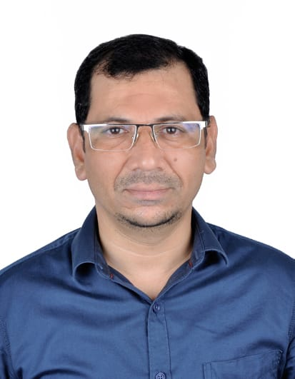
ABDUL HAMEED
Mobile (QATAR): 00974 3353 6594
(INDIA): 0091 7259704470
E-mail: hameed981@yahoo.com , hameed135@gmail.com

Career Objective

Highly skilled GRC Designer with 14 years of experience in designing and implementing innovative glass reinforced concrete solutions. Seeking a challenging position to utilize expertise in creating visually appealing and structurally sound GRC elements for architectural and construction projects.

Executive Summary

- A dynamic professional with more than 14 years of GRC, GRG & GRP experience in Design Department in gulf region.
- Currently Employed with ARABESQUE GRC QATAR (Darwish Group). As a Senior Design Engineer –GRC, GRP,GRG.
- Previously employed with TERRAZZO DUBAI CO. LLC. As GRC Designer.

Educational Qualification

Diploma in Civil Engineering (3 Year Regular) Year 1997 - 2000.

Skills

- Proficient in GRC design principles and techniques
- Strong knowledge of GRC material properties and manufacturing processes
- Skilled in using CAD (Computer-Aided Design) software for GRC modeling
- Excellent understanding of architectural and structural design principles
- Ability to interpret design specifications and create detailed GRC designs
- Strong problem-solving and critical thinking abilities
- Effective communication and teamwork skills

Professional Experience

Arabesque GRC Qatar (+9 Years) March 2014 – Till date
Senior Design Engineer - GRC.GRP, GRG

Accountabilities:
- Collaborated with main contractor or client architects and engineers to develop design concepts and specifications for GRC elements in architectural projects.
- Utilized CAD software to create detailed drawings of GRC elements, ensuring structural integrity and aesthetic appeal.
- Conducted structural analysis and calculations to determine the appropriate reinforcement and thickness for GRC components.
- Managed GRC projects from concept to completion, ensuring adherence to design standards, budgets, and timelines.
- Coordinated with production teams to ensure accurate fabrication and installation of GRC elements on construction sites.
- Mould inspection with reference to work order drawings before production of GRC elements.
- Collaborated with contractors and subcontractors to address design-related issues and provide technical support.
- Conducted site visits to monitor the progress of GRC installations and provide guidance when necessary.

TERRAZZO DUBAI CO. L.L.C, Dubai, U.A.E (+5 Years) August 2007 – April 2013
Project Engineer / Designer - GRC.

Accountabilities:
- Utilized AutoCAD software to create detailed GRC designs and specifications
- Provided technical support and guidance to clients, architects, and contractors throughout the design and construction phases.
- Developed and designed GRC architectural elements and facades for various construction projects, adhering to client specifications and project requirements.
- Coordinated with production teams to oversee the manufacturing process, ensuring compliance with design specifications and quality standards.
- Participated in client/contractor meetings and resolving client and management issues.
- Collaborated with contractors and construction teams during the installation of GRC elements, providing guidance and resolving any design-related issues.

Prestigious Project (GRC)

- PERSIAN GULF PROJECT, Shiraz, IRAN.
- Salwa resort project, salwa Qatar.
- Al Ghanim palace, Qatar.
- Doha beautification project, Doha Qatar.
- Seef lusail D3 & D4, Lusail city, Qatar.
- Abdur Rahman Al Thani Private Palace, Qatar.
- Saadiyath Beach Resort, Sadiyat Island, Abu Dhabi. UAE.
- Al Barari Villas, Dubai Land, Dubai UAE.

United Emirates Metals L.L.C, Dubai. U.A.E March 2004 – March 2007
Project Coordinator

United Consultants, Bangalore, INDIA. March 2002 – Jan 2004
Asst. Structural Engineer

Timmoji Architects, Shimoga, INDIA. Nov. 2000 – Jan 2002
Asst. Architect.

Personal Dossier

Date of Birth : 3rd January 1981
Linguistic Abilities : English, Hindi, Urdu, Kannada.
Nationality : Indian
Religious : Muslim
Marital Status : Married
Passport No. : U 0135295
Driving Licence : QATAR & UAE Driving License.

Declaration

I hereby declare that the above information are true to the best of my knowledge and belief and can be supported with relevant documents when required

ABDUL HAMEED

