**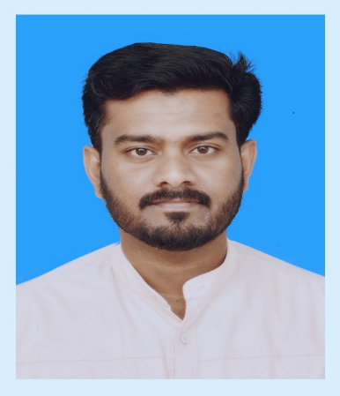***Rafeekh Kulathingal ( CMA Inter, Bcom, PGDCA), 2022*

**CURRICULUM VITAE**

**Rafeekh Kulathingal**

***CMA Inter., Bcom, PGDCA***

**Kuwait**

**E-mail: rafeek8985@gmail.com**

**MOB: +965 60950112, +965 94710029**

**Passport No. T8988919**

**ID No.290040306168**

**CAREER OBJECTIVE:**

To obtain a challenging and meaningful position and utilize my professional knowledge and experience in the field of finance that allows advancement, so that I can contribute to the growth of the organization.

**ACHIEVEMENTS:**

Completed **CMA Inter, B.com** and related Diploma Courses and **10+** Years of Gulf Experience as Accountant.

* **5 years** of experience as Accountant in a reputed multinational Main Contractor Construction Company “**SEG Qatar. W.L.L, Kuwait operation** (continuing)
* **5 years** of experience as Accountant in a reputed multinational Pre-cast company “**United Precast Concrete Qatar. W.L.L** (2012-2017)
* Having Qatar Driving License**.**

**DUTIES & RESPONSIBILITIES**

**Managing** **Cash** **Desk**:

* All petty [cash](http://www.gulftalent.com/home/Accountant-jobs-in-Qatar-128536.html) expenses recording in **ORION** and **Epromis** with accurate expense classification and adequate backups.
* Generate petty cash vouchers, secure approvals and reimbursements.
* Filing and safekeeping of Petty Cash Vouchers in numerical order.
* Process reimbursements for imprest cash holders.
* Responsibility of safekeeping of Petty Cash box

**Accounts** **Payable**:

* Review of Sub-contract agreement and Subcontractors Payment certificate (SIPC) and arrange the payment for them.
* Review LPO’s and ensure that all required approval and documents are complete such as material request, quotations, and justification note.
* Review invoices from suppliers and contractors, and ensure that the figures are balanced with LPO’s and contract terms and conditions.
* Bill registration (Invoice processing).
* Preparation of payment for suppliers as per due date of their invoices.
* Dealing with the suppliers regarding supply of materials, payments, and other business related matters.
* Filing of paid & unpaid invoices.
* Preparation of daily, weekly, monthly cash flow.
* Bank reconciliation
* Preparation of monthly operational reports and submit to the management.
* Coordination with different departments like purchase, store, production, design, project & QC etc.
* Opening of Letter of Credit to the suppliers and the subcontractors as per the contract term.
* Maintaining the file for the Bank Guarantees received from suppliers/subcontractor and arranging Bank Guarantees for the clients.
* Performs any extra task assigned by the Finance Manager.

**Accounts** **Receivable**:

* Invoice preparation as per the production or erection of elements.
* Issuance of proper receipts to customers and recording of the same thru system.
* Allocation of receipts against the client Statement of Accounts and make necessary clarification as required on partial payments made.
* Monitoring and updating client Statement of Accounts.
* Run all billing through the system. Check all invoices according to LPO submitted.
* Ensure timely deposit of all cash and cheque collections into bank.
* Receipts accounted in the system are reconciled with the Bank Statement.
* Ensure regular follow-up via telephone / email made to maintain good business relation.
* Timely reporting of accounts exceeding credit limits.
* Preparation of commercial invoice for **L/c payment**.
* Maintain the list of client’s L/c and remind then to renew before the expiry date.
* Preparation of ***Advance Bank Guarantee*** and ***Performance Bond*** for client.
* Maintain the list of guarantees for client and suppliers. And extend the period as per the request.

**General Accounting**:

* Reconciliation of all account.
* Finalization of Account
* Prepare Profit/Loss Account with the help of ERP system
* Prepare Balance sheet
* Arrange required documents for Audit work.

**EDUCATIONAL PROFILE:**

|  |  |  |  |
| --- | --- | --- | --- |
| **YEAR** | **EXAMINATION** | **INSTITUTION** | **BOARD/UNIVERSITY** |
| 2010-2012 | CMA Inter | The institute of cost accounts of India | Statutory body under an Act of Parliament |
| 2007-2010 | B.com | Presidency college of management | University of Calicut |

**PRACTICAL TRAINING:**

* P.G Diploma in Computer Application (PGDCA)
* Diploma in Computerized Financial Accounting

**COMPUTER KNOWLEDGE**

* Advanced Knowledge in MS Excel including Vlookup, Index, Sumif, Sumifs, and Pivot Table etc.
* M.S office (word, excel, power point, access)
* Adobe. Page maker.
* C, C++, VB
* Tally, Orion

**AREAS OF INTEREST:**

* Financial Accounting
* Cost and Management Accounting
* Income Tax
* Banking function

**PERSONAL DETAILS**

Date of birth : 3rd April 1990

Father’s name : Kunhimuhammed.k

Mother’s name : Fathima

Religion : Muslim

Nationality : Indian

State : Kerala

Gender : Male

Language known : Malayalam, English, Hindi, Arabic

Marital status : Married.

**PASSPORT DETAILS:**

Passport No. : T8988919

Date of issue : 20-01-2020

Date of expiry : 19-01-2030

**DECLARATION**

I hereby declare that the above statement are true, complete and correct to the best of my knowledge and belief.

Place: Kuwait

Date: 17.05.2022

Signature