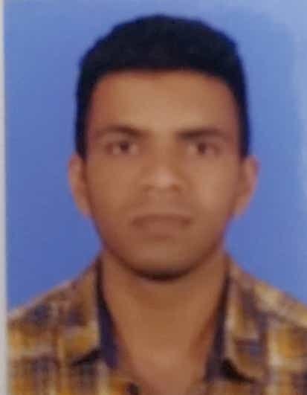 **SEBIN XAVIER**

**Mobile :**+918907101031

+918610909788 email id [sebinxk1@gmail.com](mailto:sebinxk1@gmail.com)

# OBJECTIVE

 To obtain a challenging position where my skills and talents would enable me to contribute to the growth and success of the firm as well as self-optimization.

# ACADEMIA

* Diploma in Mechanical Engineering in 2013 with First Class with distinction (**81.9%**) (State Board of Technical Education,Kerala )
* HSE in 2010 with **87**% (Board of Higher Secondary Examinations,government of Kerala) ➢ SSLC in 2008 with **88**% (Board of Public Examinations,Kerala)

# PROFESSIONAL EXPERIENCE

➢ **Maintenance technician(02/01/2015 onwards) at LAZZA ICE CREAMS PVT LIMITED**

TYPES OF WORKS

> Handling all type of maintenance activities in the factory

storage rooms,Hardener,pumps,heat exchangers,cooling towers,effluent treatment plant,chiller ,gear box ,motor,etc…

> Handling basic maintenance activities of generators,ups,cctv,printing machines,freezers,air compressors

>Installation and troubleshooting of HVAC systems which includes Compressor(Bitzer,Frascold,Danfoss,Bock,Dorin) Condensor,Expansion valves,Evaporators,Blowers,Accumulator and Filters.

>Preparation and review of engineering department SOP’s required for operation

>Troubleshooting the totally integrated Automation PLCs(ABB,SIEMENS),DTCs(Digital temperature controller)

>Hands on experience in Limit switches,Relay contacts,Proximity sensor.RPM sensor,Photo sensors, Pressure switches,Magnetic read sensor and so on.

>Detailed idea about Refrigeration flow line diagrams and Electrical circuit diagrams

>Experienced in coding parameters of Variable Frequency Drives(ABB) and wiring the VFD along with potentiometer ,Tachometer and Induction motor.

>Knowledge in pneumatic equipment starting with Air compressor (ELGI,FRANK) along with pneumatic connectors,vibrators,flow controls,pneumatic cylinders,air guns and other accessories

>Experience in various types of ice cream making machines( Stick machine, Continous freezer,cup filling machine,cone filling machines).

> working of hot water generator, plate heat exchanger

>Experience in monitoring water treatment systems such as Ozonation,UV Treatment,Filtration. Besides,knowledge in Effluent treatment reactors.

>Installing and troubleshooting Electrical equipment such as Distribution systems.FN switches,Automatic power factor regulator panel,Automatic power generator ON/OFF Units,MCCB,ELR,ELCB,MCBs,Isolators and capacitors.

>Program and replace CCTV systems including cameras.DVRs,cabling and power supplies

>Experience in Maintenance and Overhauling Homogenizer units(2500 psi),storage tanks, Refrigerated Ageing VAT

>Monitor and Maintain Coldrooms temperature of -40 degree celsius

>Performs leak checking on refrigeration lines

>Generate preventive maintenance schedule and procedure

LAZZA ICE CREAMS

Lazza is one of the most selling brand of ice creams, frozen desserts & syrups in south India. Its main business is manufacture and distribution of ice creams. The company was founded in 1972. The first factory was started in Kochi and today has over 28 factories spread across south India. The 22 factories put together has a production capacity that is among the top 5 in the country.

**Cc**

**Thejo engg. Ltd, mumbai**

**\*sr. Technical assistant(02-06-2013to 15-12-2014)**

* 2year experienced, competent Mechanical Engineer (diploma) with excellent communication, organization and co-ordination skills. Possessing a proven track record of supervising and executing projects conveyor care product installation and maintenace ensuring that work is carried out in accordance with the company’s procedures and clients satisfaction.

*awareness about installing and marketing conveyor care product such as scraper, impact cushion pads, ball mill liners, dust suppression system , etc

# COMPUTER PROFILE

* MS Office package (especially Word & PowerPoint)
* Computer & Internet Fundamentals

# STRENGTHS

* Self-motivated
* Leadership
* Hardworking
* Sincere
* Quick learner

**INDUSTRIAL TRAINNG**

* Industrial training in ksrtc kottayam,

# HOBBIES

* Swimming
* Fishing
* Listening to music
* Playing Cricket, Football etc

# PERSONAL PROFILE

|  |  |
| --- | --- |
| ▪ D.O.B | : 25/05/1993 |
| ▪ Sex | : Male |
| ▪ Marital Status | : Single |
| ▪ Nationality | : Indian |
| ▪ Languages Known | : Malayalam(expert),English(proficient),Hindi(proficient), and |

Tamil(beginner)

▪ Permanent Address : kattady house,

Oorukkay p.o, vezhapra, alappuzha dist.,kerala state 689595