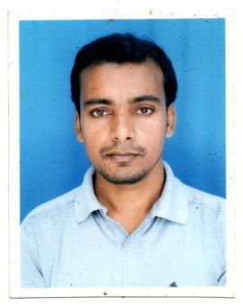**NAME : RAJESH ALI**

**PHOTO**

**FATHER’S NAME : ASGAR ALI**

**DATE OF BIRTH : 02/03/1991**

**PERMANET ADDRESS : VILL - CHANCHAL NAYATOLA**

**P.O - CHANCHAL**

**P.S. - CHANCHAL**

**DIST - MALDA**

**PIN - 732123**

**STATE - WEST BENGAL, INDIA**

**CONTACT NO: 9851621939/9775810353**

**EMAIL-ID: rajeshwwe05@gmail.com**

**CASTE : OBC**

**SEX : MALE**

**RELIGION : ISLAM**

**NATIONALITY : INDIAN**

**MARITAL STATUS : UNMARRIED**

**LANGUAGE KNOWN : BENGALI, HINDI & ENGLISH**

**EDUCATIONAL QUALIFICATION : GRADUATION PASSED**

**EXPERIENCE/OTHER QUALIFICATIONS:i) DIPLOMA IN COMPUTER APPLICATIONS (01 YEAR)**

**II) 05 YEARS WORKING EXPERIENCE AS AN OFFICE ATTENDANT/WORKER**

**III) HAS 2 YEARS EXPERIENCE RUNNING HDFC BANK CUSTOMER SERVICE POINT**

**IV) HAS 2 YEARS EXPERIENCE WORKING IN AADHAAR ENABLED PAYMENT SYSTEM**

**V) HAS 2 YEARS OF EXPERIENCE RUNNING HIS OWN SHOP (XEROX, PHOTO STUDIO, ONLINE WORK STORE/SHOP)**

**DECLARATION**

**I do hereby declare that all the statement made above is correct to the best of my knowledge and belief.**

**DATE :**

**PLACE : SIGNATURE**